> library(MASS)

> head(mammals)

body brain

Arctic fox 3.385 44.5

Owl monkey 0.480 15.5

Mountain beaver 1.350 8.1

Cow 465.000 423.0

Grey wolf 36.330 119.5

Goat 27.660 115.0

> attach(mammals)

> model = lm(brain~body)

> model

Call:

lm(formula = brain ~ body)

Coefficients:

(Intercept) body

91.0044 0.9665

Brain_hat = 91.0044 + 0.9665*body



> confint(model,'body',level = 0.95)

2.5 % 97.5 %

body 0.8711564 1.061836



> confint(model,'body',level = 0.9)

5 % 95 %

body 0.8868684 1.046124



> res = resid(model)

> fit = fitted(model)

> plot(fit,res)

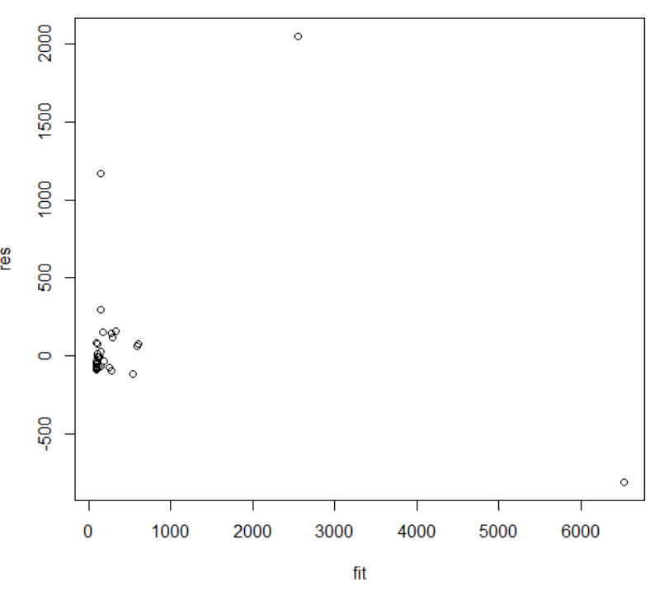



That one which has 2500 body fat has the largest residual.



> attach(cars)

> plot(speed,dist)

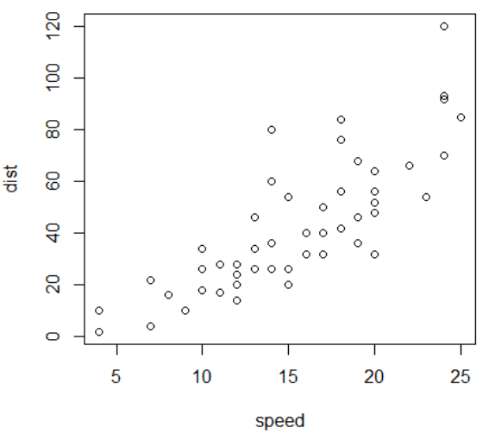



> model = lm(dist~speed)

> model

Call:

lm(formula = dist ~ speed)

Coefficients:

(Intercept) speed

-17.579 3.932

Dist_hat = -17.579 + 3.932*speed



> abline(model)

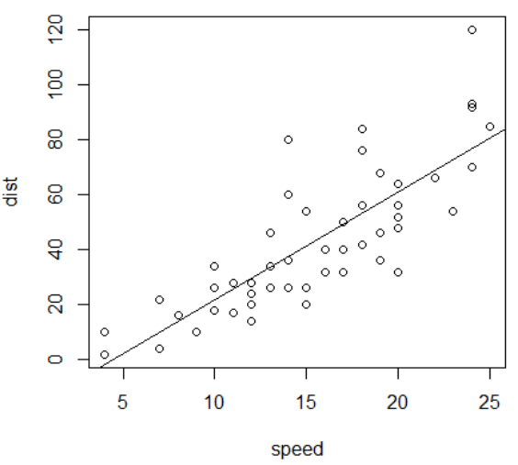



> head(resid(model),5)

1 2 3 4

3.849460 11.849460 -5.947766 12.052234

5

2.119825

> head(fitted(model),5)

1 2 3 4

-1.849460 -1.849460 9.947766 9.947766

5

13.880175



> plot(resid(model))

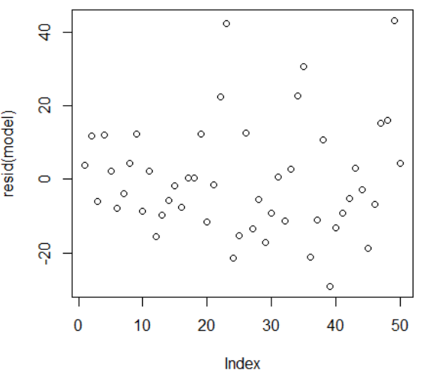

> plot(fitted(model))

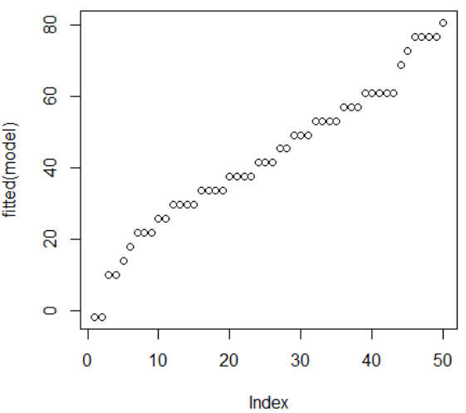



For no intercept models:  
> model2 = lm(dist~0+speed)

> model2

Call:

lm(formula = dist ~ 0 + speed)

Coefficients:

speed

2.909

The coefficient is 2.909.

For intercept model, the coefficient is 3.932.



> density = c(9.50, 9.80, 8.30, 8.60, 7.00, 17.40, 15.20, 16.70, 15.00, 14.80, 25.60, 24.40, 19.50, 22.80, 19.80,40, 11.00, 9.90, 6.40, 8.20, 15.00, 16.40, 15.40, 14.50, 13.60, 23.40, 23.30, 21.20, 21.70, 21.30)

> stiffness = c(14814, 14007, 7573, 9714, 5304, 43243, 28028, 49499, 26222, 26751, 96305, 72594, 32207, 70453, 38138, 17502, 19443, 14191, 8076, 10728, 25319, 41792, 25312, 22148, 18036, 104170, 49512, 48218, 47661, 53045)

> plot(density, stiffness)

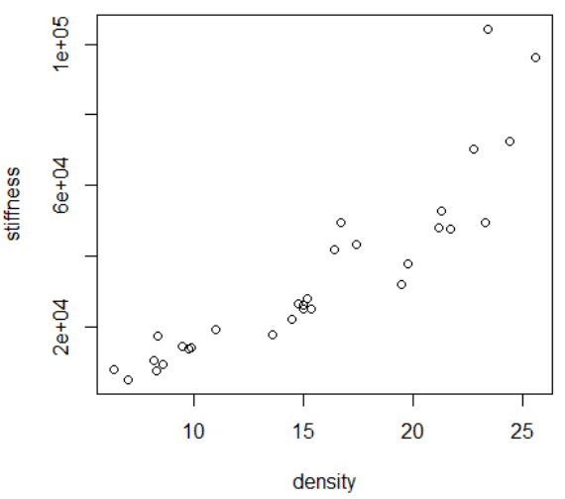



> model = lm(stiffness~density)

> model

Call:

lm(formula = stiffness ~ density)

Coefficients:

(Intercept) density

-25434 3885

Stiffness_hat = -25434 + 3885*density

> abline(model)

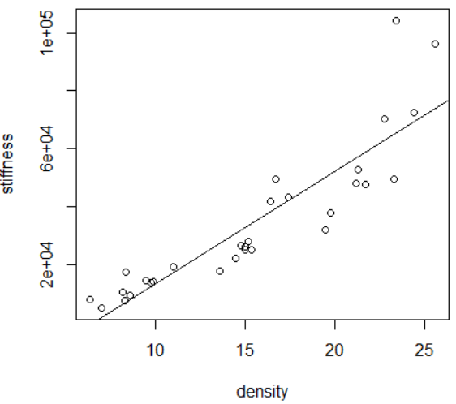



> anova(model)

Analysis of Variance Table

Response: stiffness

Df Sum Sq Mean Sq F value Pr(>F)

density 1 1.4892e+10 1.4892e+10 110.24 3.245e-11 ***

Residuals 28 3.7823e+09 1.3508e+08

---

Signif. codes:

0 ?**?0.001 ?*?0.01 ??0.05 ??0.1 ??1

The residual error is quite large, which means the model is not very appropriate.



> x = density

> y = stiffness

> b = boxcox(lm(y~x))

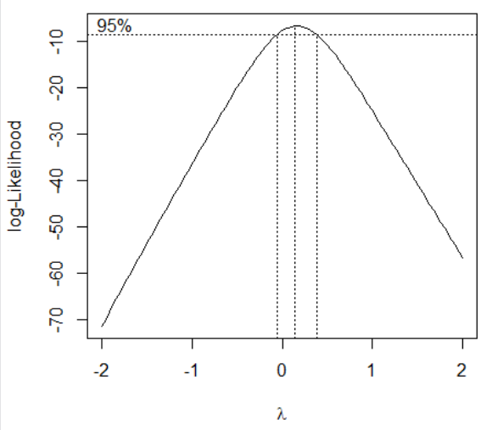

Model can be improved

λ = 0.1

> y1 = y^0.1

> plot(x,y1)

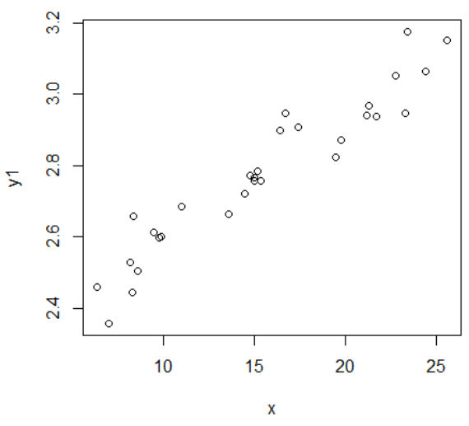



> data = read.table('C:\\Users\\Administrator\\Documents\\git\\R\\statistical computing\\HW05\\electric.txt',header=T)

> model = lm(y~x1+x2+x3+x4)

> model

Call:

lm(formula = y ~ x1 + x2 + x3 + x4)

Coefficients:

(Intercept) x1 x2 x3

-102.71324 0.60537 8.92364 1.43746

x4

0.01361

Y_hat = -102.71324 + 0.60573*x1 + 8.92364*0.2 + 1.43746*x3 + 0.01361*x4



> predict(model,data.frame(x1=75,x2=24,x3=90,x4=98))

1

287.5618



> predict(model,data.frame(x1=75,x2=24,x3=90,x4=98),interval = 'pred')

fit lwr upr

1 287.5618 243.7175 331.4062

> predict(model,data.frame(x1=75,x2=24,x3=90,x4=98),interval = 'confidence',level = 0.95)

fit lwr upr

1 287.5618 263.7879 311.3357



> data = read.table('C:\\Users\\Administrator\\Documents\\git\\R\\statistical computing\\HW05\\hits.txt',header=T)

> names(data)

[1] "Week" "Hits"

> attach(data)

> plot(Week,Hits)

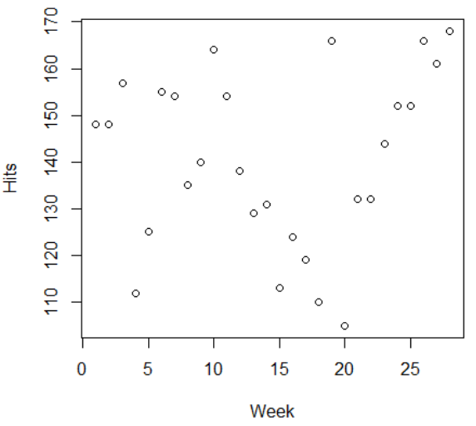



> cor.test(Week,Hits,method='spearman',conf.level = 0.95)

Spearman's rank correlation rho

data: Week and Hits

S = 3129.6, p-value = 0.4663

alternative hypothesis: true rho is not equal to 0

sample estimates:

rho

0.1435027

H0 : the correlation is zero

Ha : the correlation is not zero

p-value > 0.05, do not have enough evidence to reject null hypothesis.

> cor.test(Week,Hits,method='pearson',conf.level = 0.95)$conf

[1] -0.2568020 0.4787058

attr(,"conf.level")

[1] 0.95